“ Chedars, Chuppahs & Chatans”

“The Bridal Chamber, The Marriage Canopy & The Bridegroom”
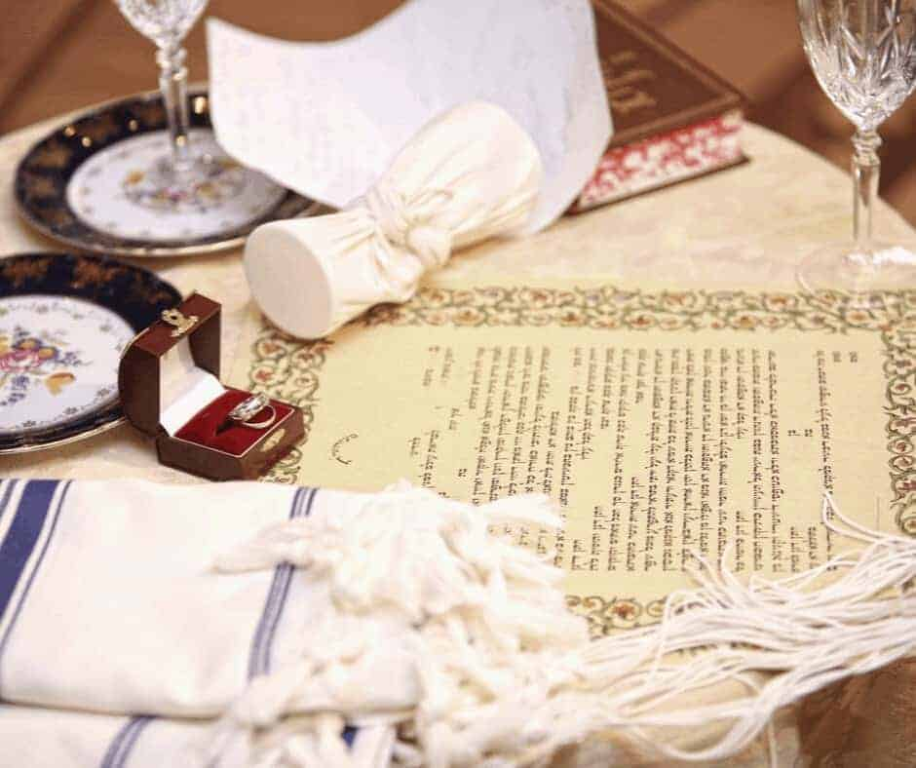

What amazing Bible Prophecy parallels the Old Testament presents for the ancient Jewish Wedding. We know that Jesus is the Bridegroom (chatan): He will return to gather His betrothed, The Church, to enter the Father’s House. He is coming for a pure bride without spot or wrinkle. When the Father gives the command with the sound of a shofar, the Son will take His bride into the Father’s house, and the doors will be shut. There under a wedding canopy, the Chuppah, the wedding is consecrated with great celebration and joy. Immediately after, they enter the bridal chamber, the cheder, for an intimate 7- day honeymoon, while the bridal party celebrates outside with great feasting and joy. At the end of the 7 days, the bridegroom and his bride leave the bridal chamber, announcing that the bride is now become His wife!

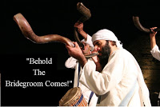

TOOLS
Matthew 25:6 “And at midnight there was a cry made, Behold, the bridegroom cometh; go out to meet Him.”

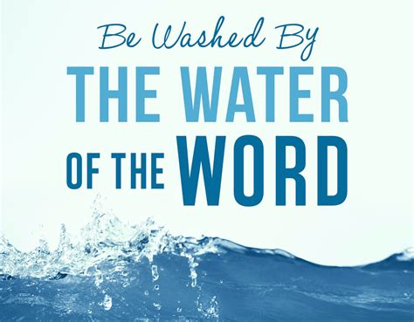
“ A Bride without Spot or Wrinkle
Is a Bride Washed By the Word “

Ephesians 5:22-32
²² Wives, submit yourselves unto your own husbands, as unto the Lord.
²³ For the husband is the head of the wife, even as Christ is the head of the church: and He is the savior of the body.
²⁴ Therefore as the church is subject to Christ, so let the wives be to their own husbands in every thing.
²⁵ Husbands, love your wives, even as Christ also loved the church, and gave Himself for it;
²⁶ That He might sanctify and cleanse it with the washing of water by the Word,
²⁷ That He might present it to Himself a glorious Church, not having spot, or wrinkle, or any such thing; but that it should be holy and without blemish.
²⁸ So ought men to love their wives as their own bodies. He that loves his wife loves himself.
²⁹ For no man ever yet hated his own flesh; but nourishes and cherishes it, even as the Lord the Church:
³⁰ For we are members of His body, of His flesh, and of His bones.
³¹ For this cause shall a man leave his father and mother, and shall be joined unto his wife, and they two shall be one flesh.
³² This is a great mystery: but I speak concerning Christ and the Church.T
“Protecting the Betrothed”

2 Corinthians 11:1 “Would to God you could bear with me a little in my folly: and indeed bear with me. (Paul) TOOLS
2. For I am jealous over you with godly jealousy: for I have espoused you to one husband, that I may present you as a chaste virgin to Christ.TOOLS
3. But I fear, lest by any means, as the serpent beguiled Eve through his subtilty, so your minds should be corrupted from the simplicity that is in Christ.

“The Marriage Supper of the Lamb “

Revelation 19:7-9 “Let us be glad and rejoice, and give honor to Him: for the marriage of the Lamb has come, and His wife has made herself ready. And to her was granted that she should be arrayed in fine linen, clean and white: for the fine linen is the righteousness of the saints. And he said to me, Write, Blessed are they which are called unto the Marriage Supper of the Lamb. And he said to me, These are the true sayings of God.”

By studying the ancient Jewish wedding patterns, we hope to gain an understanding of the heart of God towards The Church and His perfect timing of the forever union between Jesus and His Church forever. Also is our study is an amazing picture of God’s strong defence of His Church: “ the snatching away just in time in the Rapture,” and safely hidden from danger during the whole 7 Year Tribulation on earth.
Revelation 3:10 ”Because you have kept the Word of My patience, I will also keep you from the hour of temptation, which shall come upon all the world, to try them that dwell on the earth.”
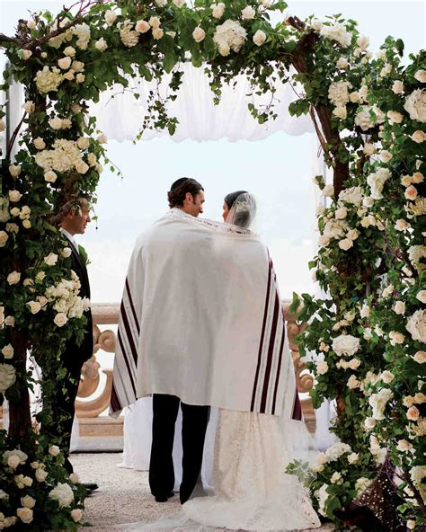
“The Chuppah – The Wedding Canopy”

Psalm 19:5 “Which is as a bridegroom coming out of his
chamber (chuppah and rejoices as a strong man to run a race.
TOOLS
Isaiah 4:5 “ And the LORD will create upon every dwelling place of Mount Zion, and upon her assemblies, a cloud and smoke by day,and the shining of a flaming fire by night:
for upon all the glory shall be a defence (chuppah)
TOOLS
Joel 2:16 “Gather the people, sanctify the congregation, assemble the elders, gather the children, and those that suck the breasts: let the bridegroom go forth out of his chamber (chedar), and the bride out of her closet. (chuppah) H2646”

The Chedar - the Bridal Chamber

Isaiah 26:20 “Come, My people, enter into your chambers, (chedar H2315) and shut your doors about you: hide yourself as it were for a little moment, until the indignation be overpast.”

Song of Songs 1:4 “Draw me, we will run after thee: the King has brought me into his chambers (chedar H2315). We will be glad and rejoice in You, we will remember Your love more than wine: the upright love You.
TOOLS
Joel 2:16 “Gather the people, sanctify the congregation, assemble the elders, gather the children, and those that suck the breasts: let the bridegroom go forth out of his chamber (chedar), and the bride out of her closet. (chuppah) H2646”
Rejoicing Over the Bride
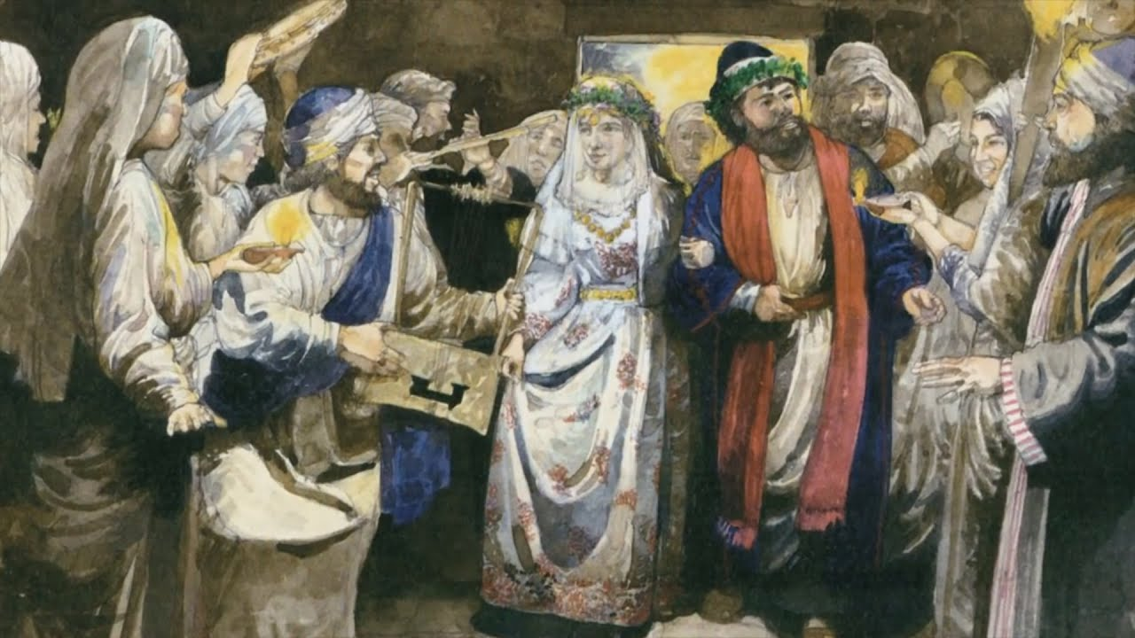

Isaiah 62:5 “For as a young man marries a young woman, so shall your sons marry you, and as the bridegroom rejoices over the bride, so shall your God rejoice over you.”

Isaiah 61:10 I will greatly rejoice in the Lord; my soul shall exult in my God, for He has clothed me with the garments of salvation; He has covered me with the robe of righteousness, as a bridegroom decks himself like a priest with a beautiful headdress, and as a bride adorns herself with her jewels.”
John 3:29 “He that has the bride is the bridegroom: but the friend of the bridegroom, which stands and hears Him, rejoices greatly because of the bridegroom's voice: this my joy therefore is fulfilled.
Revelation 19:7 “Let us be glad and rejoice, and give honor to Him: for the marriage of the Lamb is come, and his wife has made herself ready.”

Matthew 9:15 And Jesus said to them, “Can the wedding guests mourn as long as the bridegroom is with them? The days will come when the bridegroom is taken away from them, and then they will fast.

Psalm 19:5 “Which comes out like a bridegroom leaving his chamber chuppah, and, like a strong man, runs its course with joy.”

Deuteronomy 24:5 “When a man is newly married, he shall not go out with the army or be liable for any other public duty. He shall be free at home one year to be happy with his wife whom he has taken.TOOLS
Song of Songs 2:8-10 “The voice of my beloved! Behold, He comes leaping upon the mountains, skipping upon the hills. My beloved is like a roe or a young hart: behold, He stands behind our wall, he looks forth at the windows, showing Himself through the lattice.
My beloved spoke, and said unto me, Rise up, My love, My fair one, and come away.

